**React Forms**

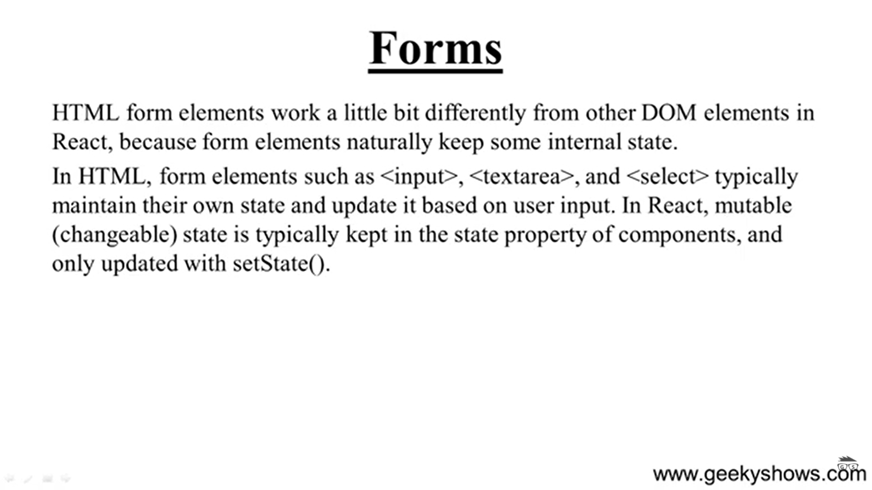

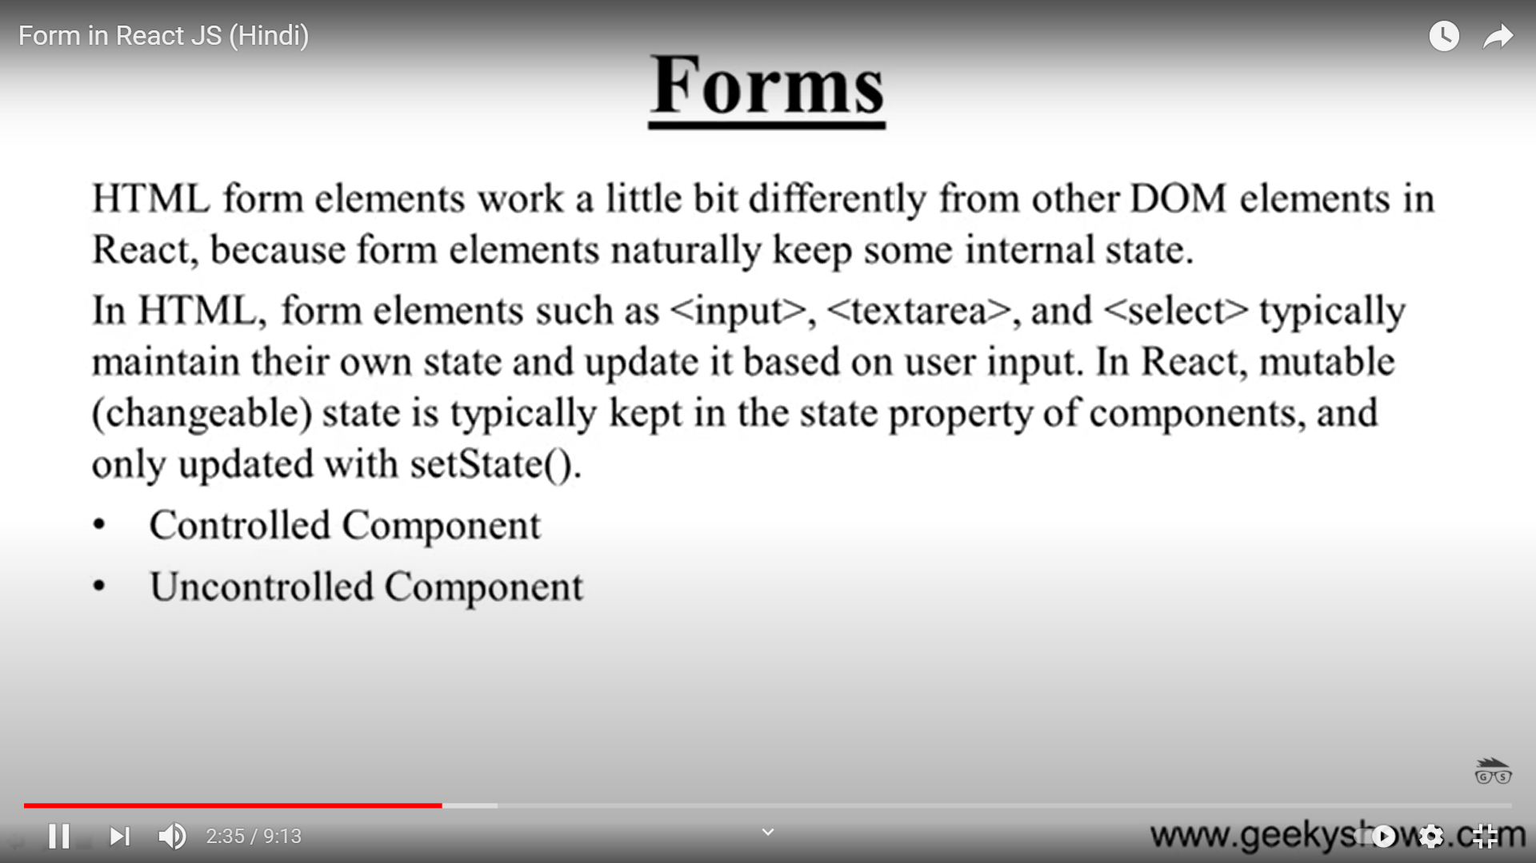

Controlled Component > The data that comes , how you control that

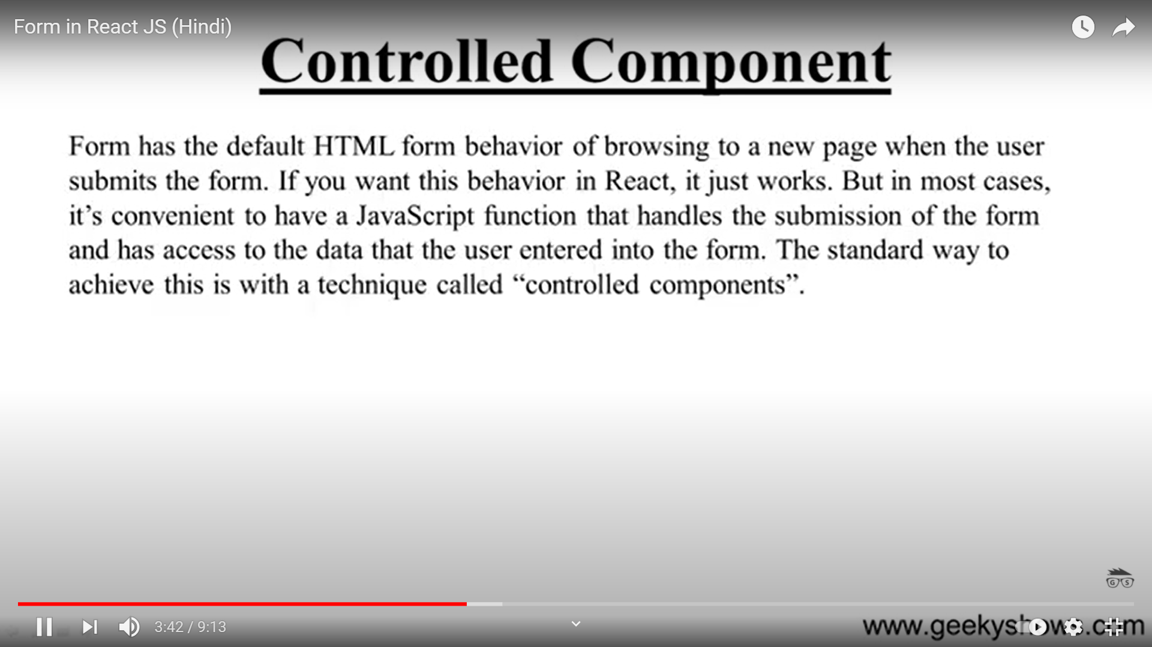

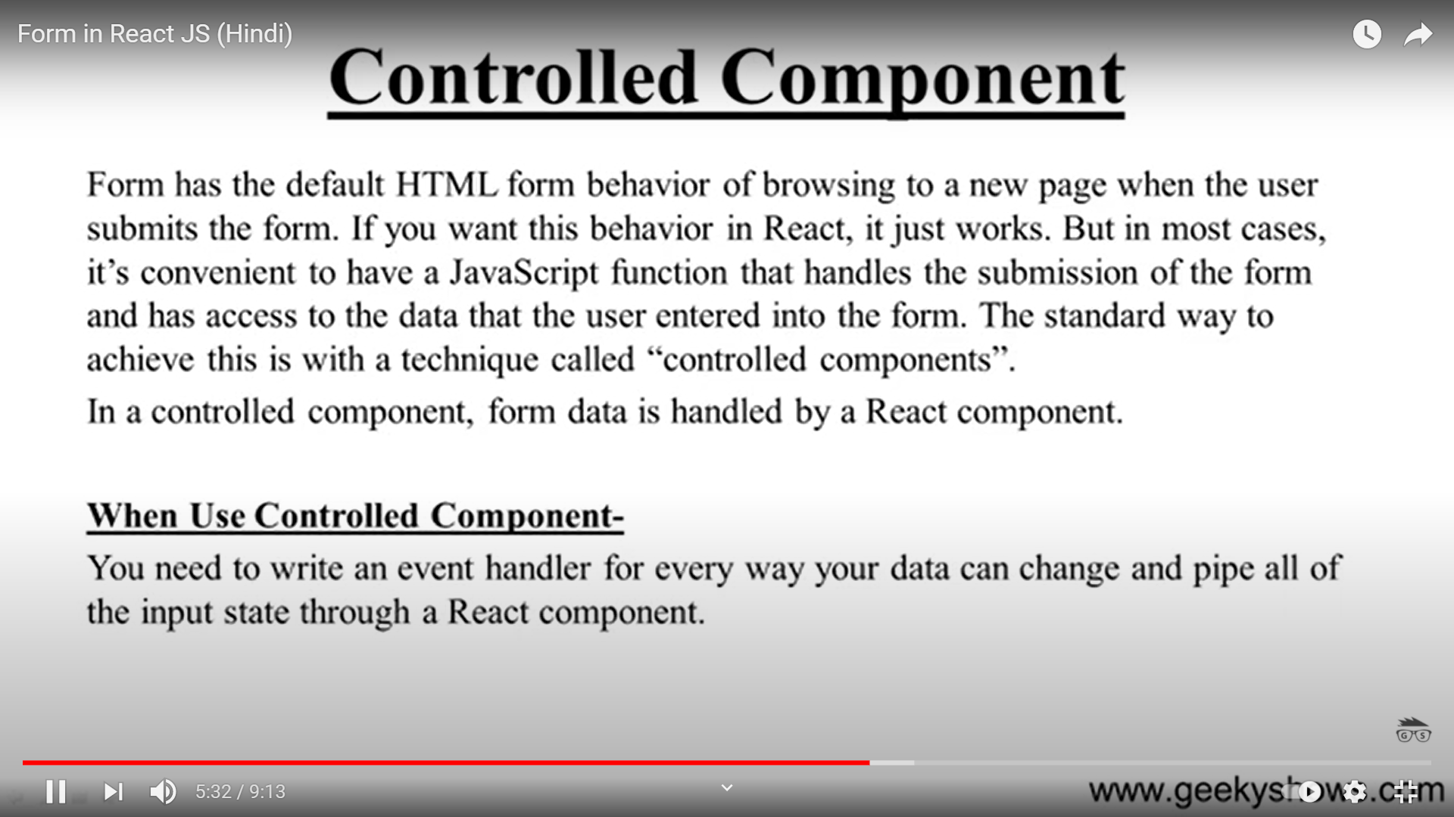

Controlled Inputs

An input is said to be “controlled” when React is responsible for maintaining and setting its state. The state is kept in sync with the input’s value, meaning that changing the input will update the state, and updating the state will change the input.

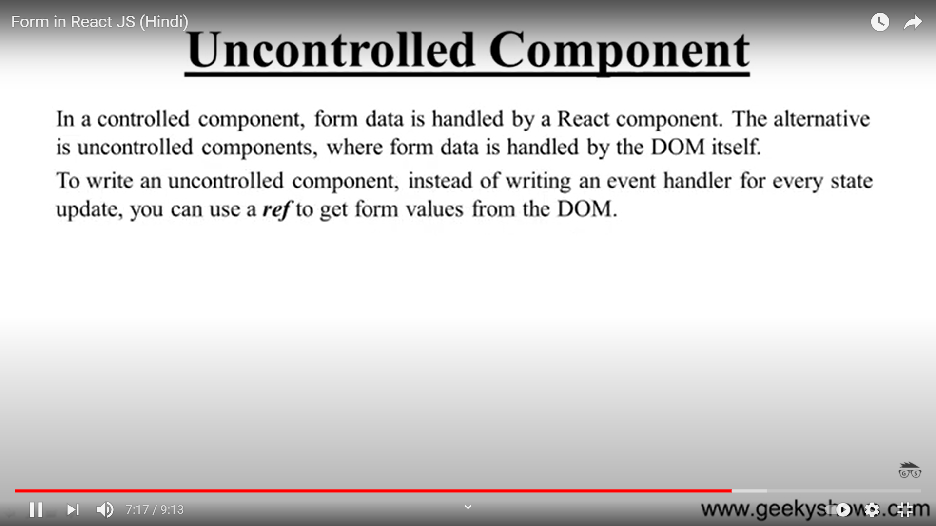

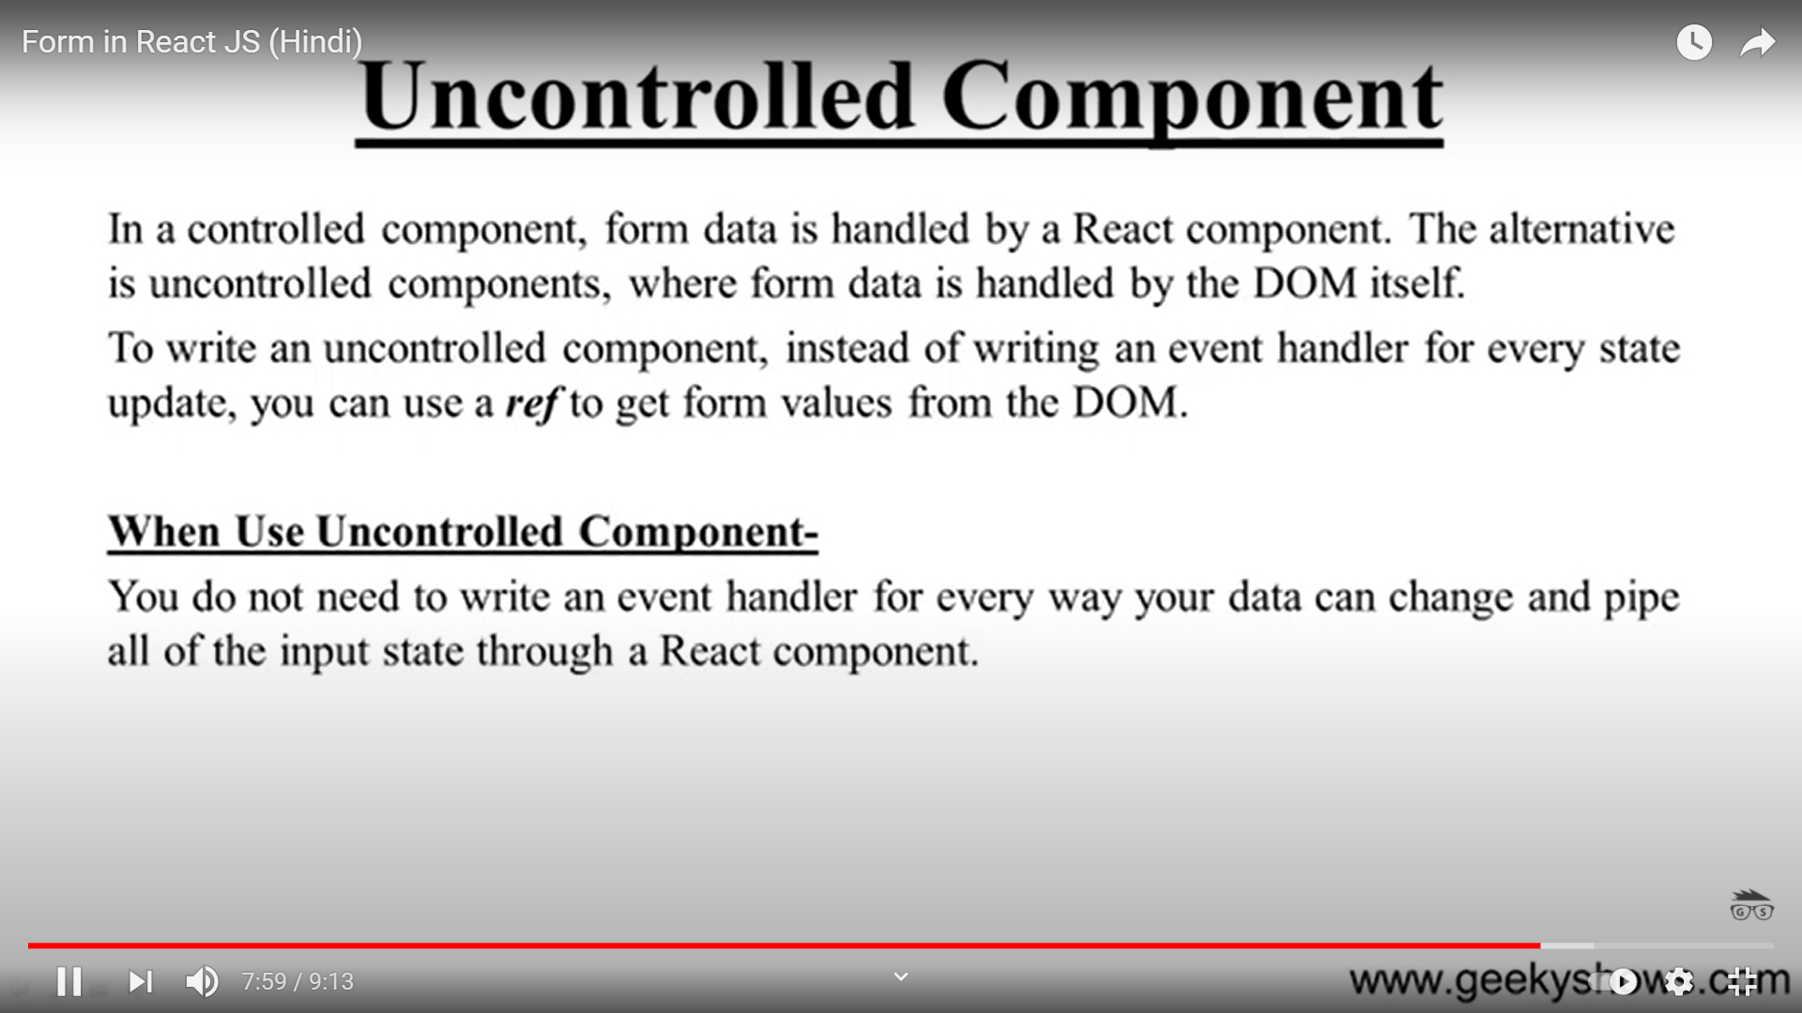

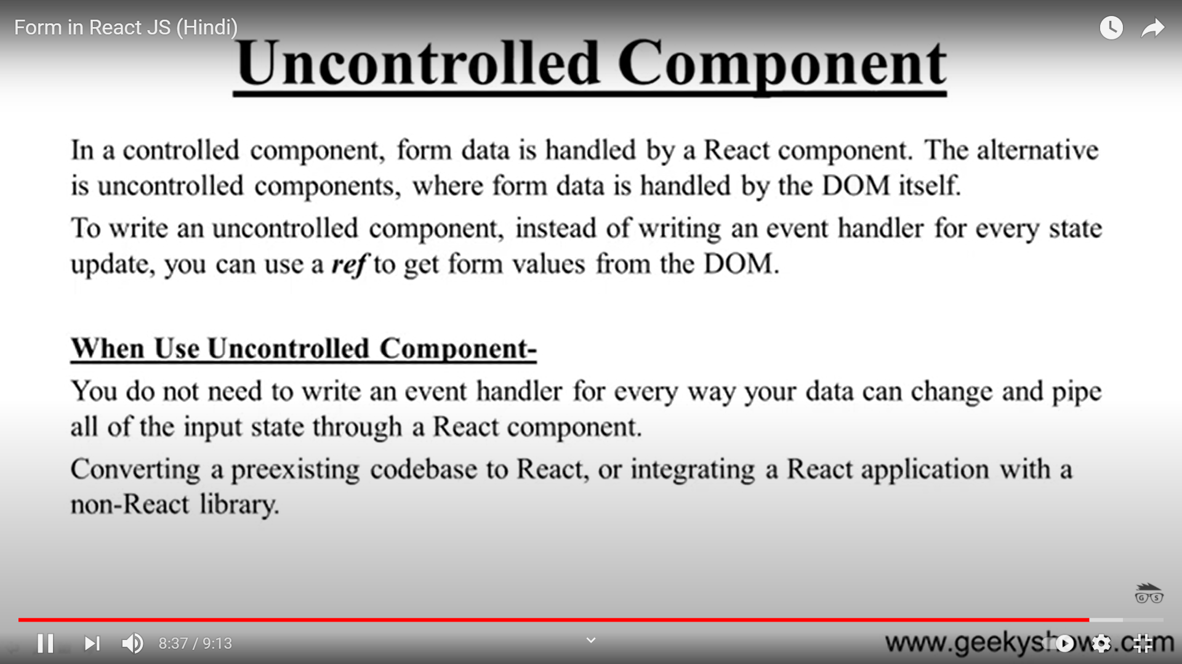

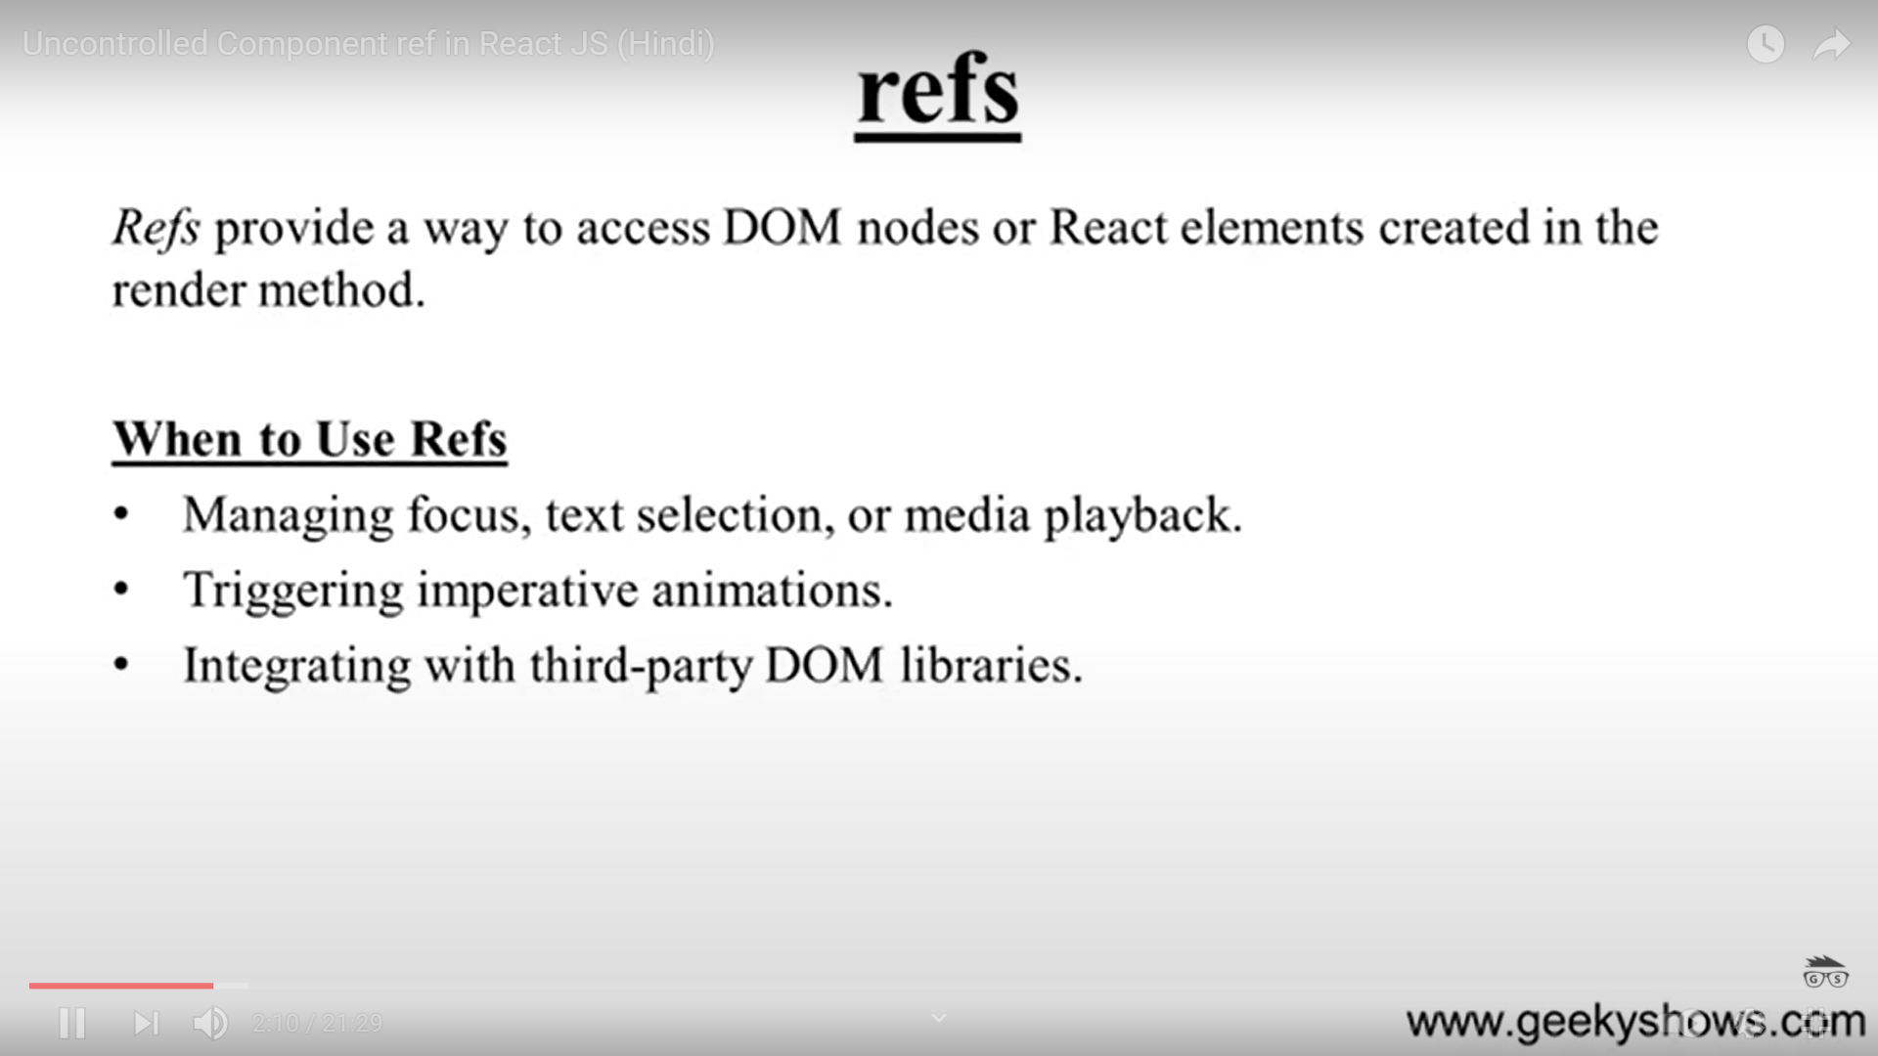

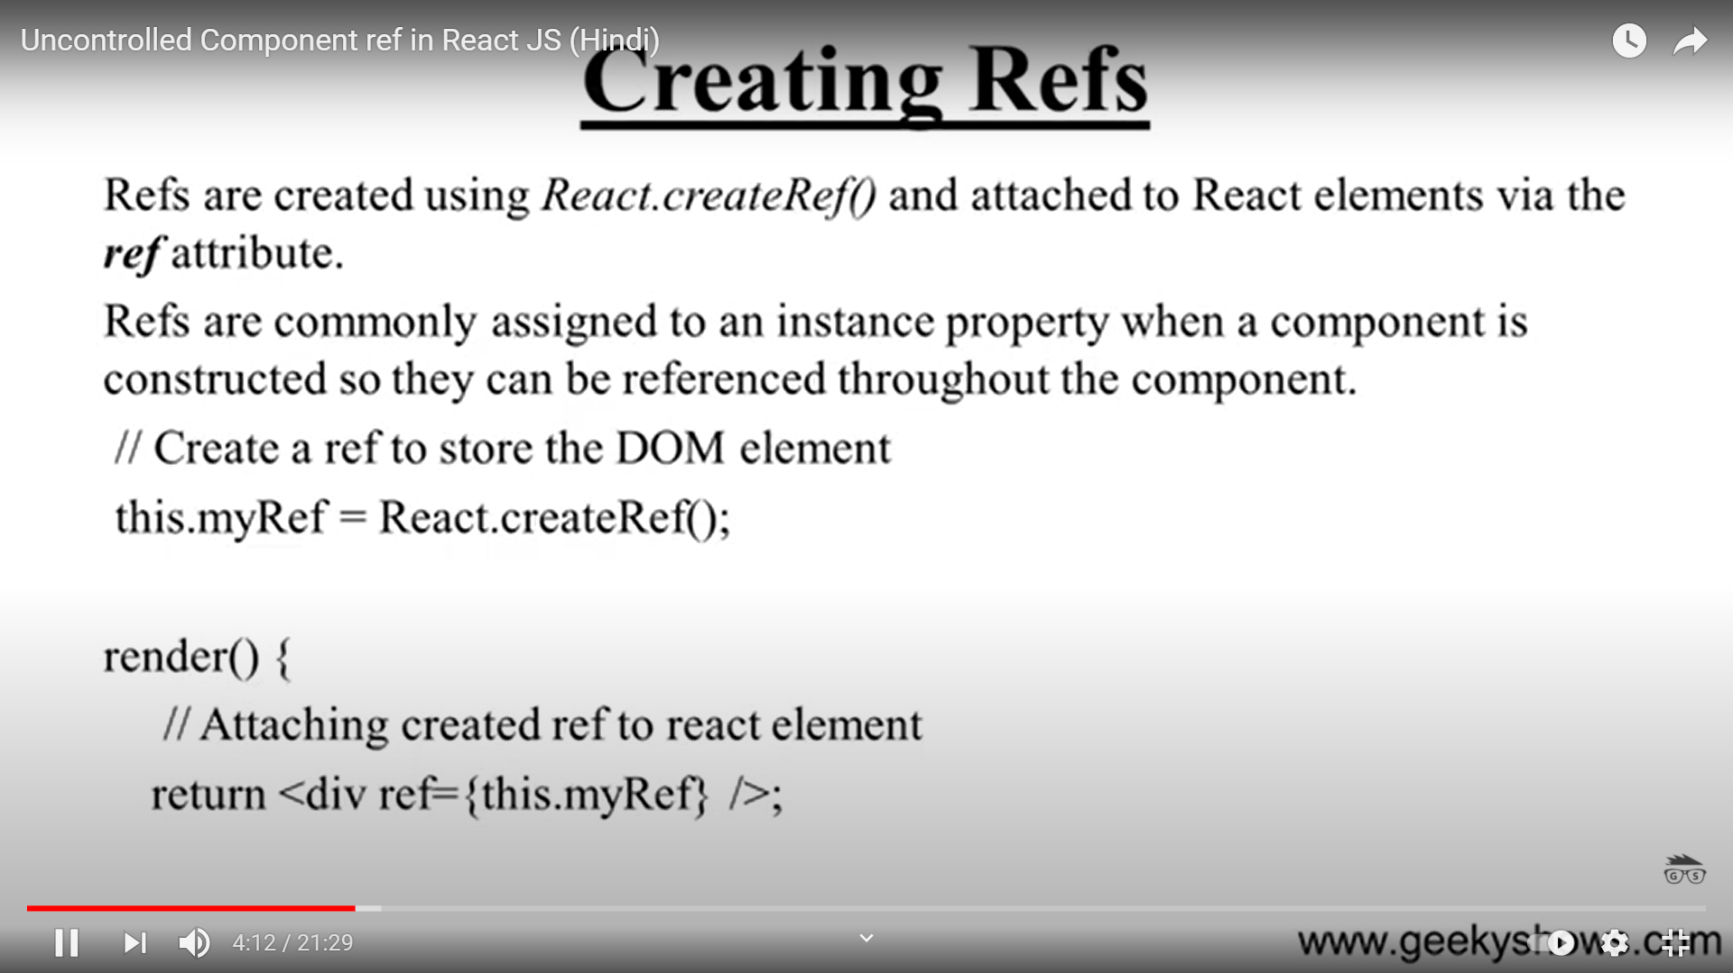

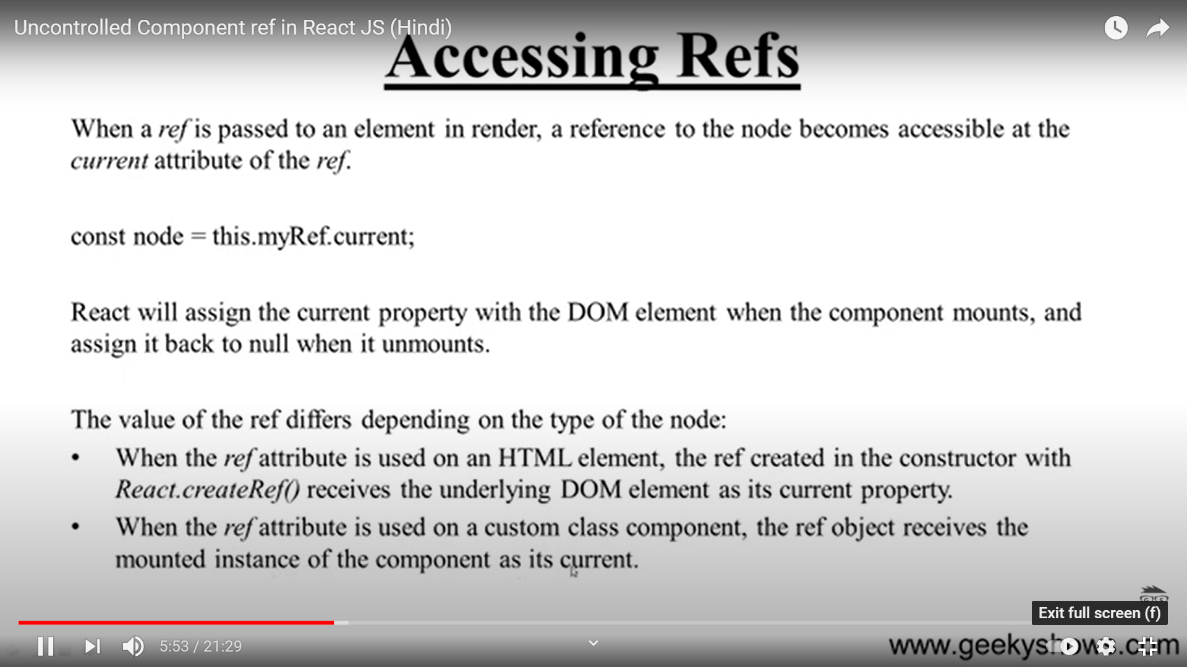

The most basic way of working with forms in React is to use what are referred to as “uncontrolled” form inputs. What this means is that React doesn’t track the input’s state. HTML input elements naturally keep track of their own state as part of the DOM, and so when the form is submitted we have to read the values from the DOM elements themselves.

In order to do this, React allows us to create a “ref” (reference) to associate with an element, giving access to the underlying DOM node.

* **instant input validation**: we can give the user instant feedback without having to wait for them to submit the form (e.g. if their password is not complex enough)
* **instant input formatting**: we can add proper separators to currency inputs, or grouping to phone numbers on the fly
* **conditionally disable form submission**: we can enable the submit button after certain criteria are met (e.g. the user consented to the terms and conditions)
* **dynamically generate new inputs**: we can add additional inputs to a form based on the user’s previous input (e.g. adding details of additional people on a hotel booking)